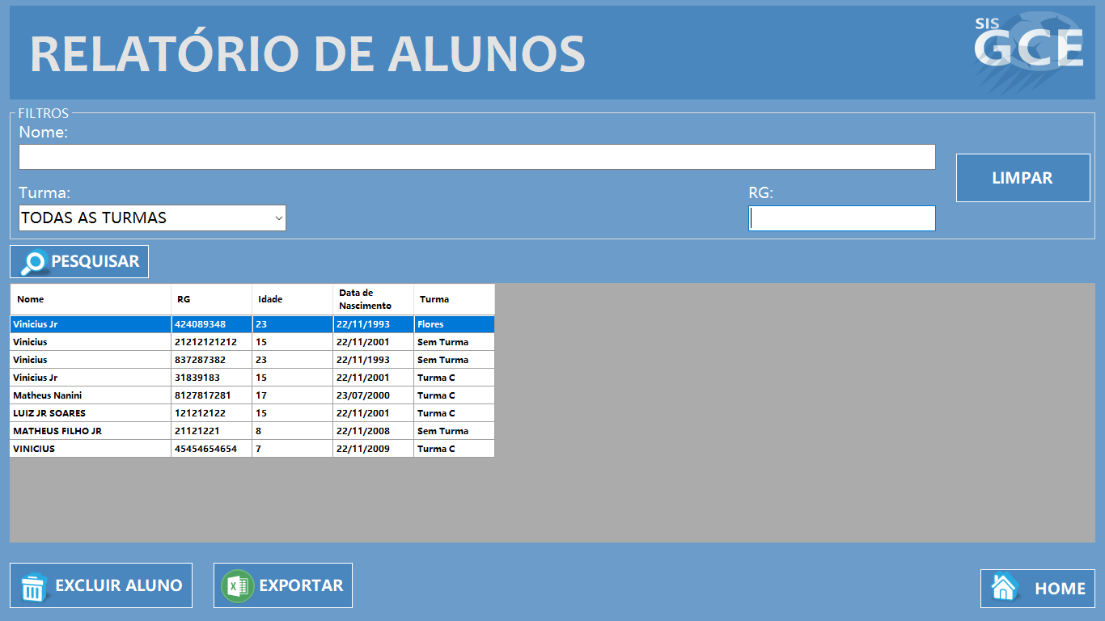

|  |  |  |  |  |
| --- | --- | --- | --- | --- |
| **CT NO.** | **PROPÓSITO** | | | |
| **01** | **VERIFICAR O RELATORIO DO ALUNO** | | | |
| **PRÉ-CONDIÇÕES** | | | | |
| **NÃO TEM** | | | | |
| **ENTRADA1** | | **ENTRADA2** | **ENTRADA3** | **ENTRADA4** |
| **NOME** | | **RG** | **TURMA** | **BOTAO LIMPAR** |
| **ENTRADA5** | | **ENTRADA6** | **ENTRADA7** | **ENTRADA 8** |
| **BOTAO PESQUISAR** | | **BOTAO EXCLUIR** | **BOTAO EXPORTAR** | **BOTAO HOME** |
| **SAÍDAS ESPERADAS** | | | | |
| **RELATORIO GERADO** | | | | |

|  |  |  |  |  |  |
| --- | --- | --- | --- | --- | --- |
| **TESTE No.** | **NOME** | **RG** | **TURMA** | **BOTAO** | **SAÍDAS ESPERADAS** |
| **1** | **LUIZ CARLOS** | **40.634.241-6** | **TURMA D** | **PESQUISAR** | **RELATORIO GERADO** |

|  |  |  |  |  |  |
| --- | --- | --- | --- | --- | --- |
| **TESTE No.** | **NOME** | **RG** | **TURMA** | **BOTAO** | **SAÍDAS ESPERADAS** |
| **2** | **VINICIUS** | **40.634.241-8** | **TURMA A** | **PESQUISAR** | **RELATORIO GERADO** |

|  |  |  |  |  |  |
| --- | --- | --- | --- | --- | --- |
| **TESTE No.** | **NOME** | **RG** | **TURMA** | **BOTAO** | **SAÍDAS ESPERADAS** |
| **3** |  |  | **TURMA C** | **PESQUISAR** | **MENSAGEM DE ERRO** |

|  |  |  |  |  |  |  |
| --- | --- | --- | --- | --- | --- | --- |
| **TESTE No.** | **NOME** | **RG** | **TURMA** | **BOTAO** | **BOTAO** | **SAÍDAS ESPERADAS** |
| **4** | **MAX** | **40.634.100-2** | **TURMA B** | **PESQUISAR** | **EXPORTAR** | **RELATORIO EXPORTADO** |

|  |  |  |  |  |  |  |
| --- | --- | --- | --- | --- | --- | --- |
| **Aplicado em** | **Aplicado**  **por** | **Quantidade**  **de falhas** | **Depurado por** | **Reaplicado**  **em** | **Reaplicado**  **por** | **Quantidade**  **de falhas** |
| **27/10/2017** | **Matheus** | **0** | **Gustavo** |  |  |  |